Muscular Strength and the FITT Principal

This week we are going to concentrate on muscular Strength in our fitness plan.
Muscular Strength: is the ability of a muscle, or a group of muscles, to exert force for
a brief period of time. See all the examples below for muscular endurance and plan you workout using the FITT principle.
When engaging in resistance training, exercises must be performed to the point of
fatigue or failure (i.e., cannot complete one more repetition), regardless of whether one
is training for strength or for endurance. If it feels as if four more repetitions could have
been performed after the set is completed, then there was not enough overload.

How do I know the difference in muscular strength or muscular endurance?

Think about the amount of weight you are lifting and how many reps you are performing. Lighter weights and a bunch of reps (somewhere in the 15 to 20 range) …. that is endurance. Lifting heavier weight and only a few reps (around 5 to 8) …. that is strength.

Let’s do some Strength Training:
Full-body dumbbell exercises are a great way to work on strength training for your CORE, LOWER BODY and UPPER BODY. These dumbbell exercise posters below feature easy-to-follow instructions and will help you develop proper form. All 9 dumbbell exercises can be performed in the comfort of your own home. Don’t have access to dumbbells? I have listed common items you can find around your home for easy substitutions! You can also use your body weight as the resistance. See examples below.
Dumbbell Substitutions:
- Canned Goods
- Water Bottles
- Milk Jugs
- Laundry Detergent jugs

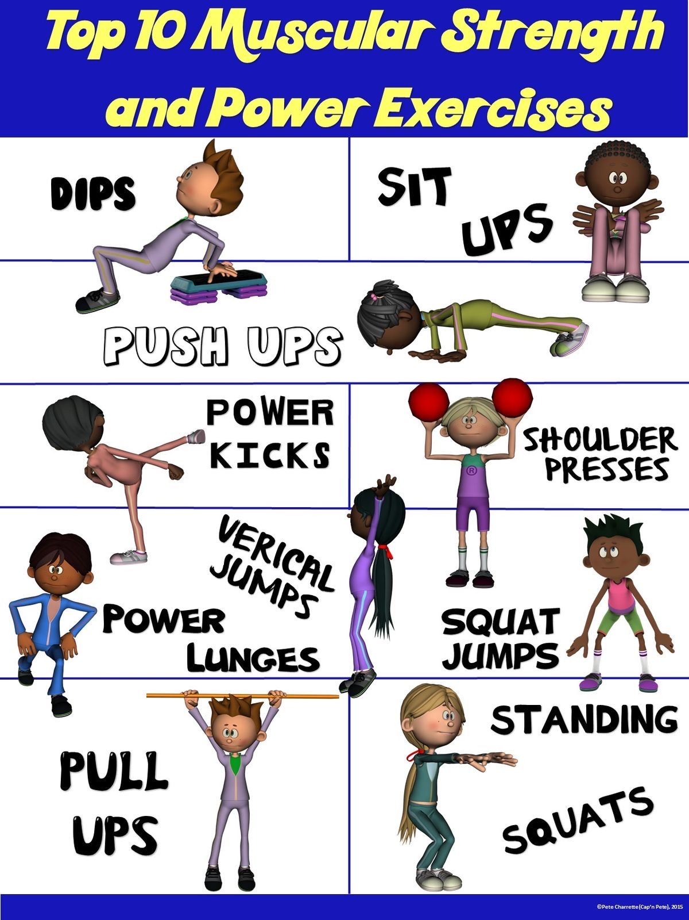

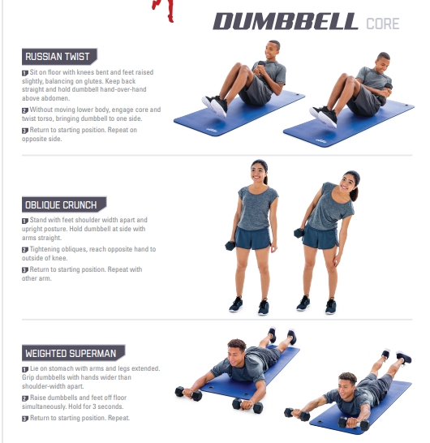

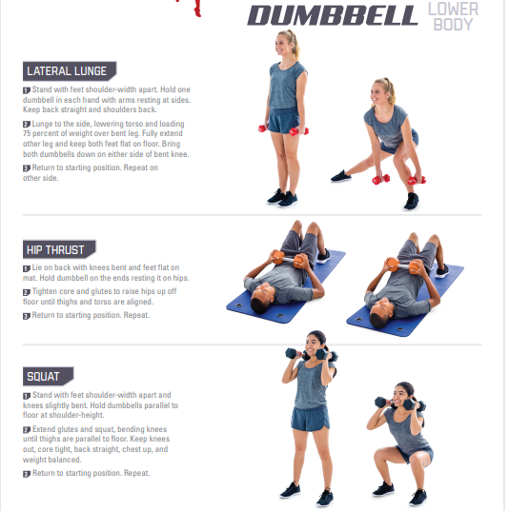

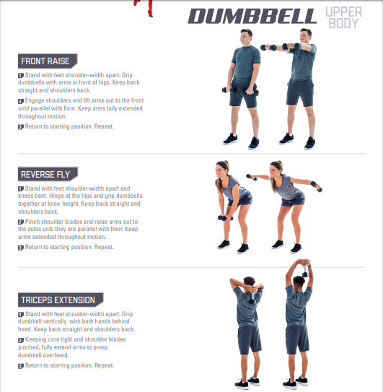
Warm-up/Cool-down
Students should always warm-up before beginning to exercise to prevent injury. An effective warm-up increases the muscle temperature. A warm-up should consist of light physical activity for 5 to 10 minutes of exercise, such as walking, slow jogging, knee lifts, arm circles, or trunk rotations. Low-intensity movements that simulate movements to be used in the activity can also be included in the warm-up. This increase in temperature improves circulation to the working muscles, increases muscle elasticity, and prepares tendons and ligaments for activity. The warmup should be long enough for students to begin to sweat. You should always do some light aerobic exercise (exercise which increases the heart rate and raises the breathing rate) before starting to workout. Remember…. warm muscles work better.
This week we want you to focus on muscular endurance. Fill in the boxes under muscular strength using the chart “A Balanced Fitness Program: What to consider”. See my example for help. We will plan a program for each component every week. Continue to fill in your exercise log.
A Balanced Fitness Program: What to consider
F.I.T.T | Cardiovascular  Endurance | Flexibility | Muscular Endurance | Muscular  Strength | Body  Composition
F  Frequency | 3-5 days per week | Do every day  Should be a part of every warmup and cool down | 3-4 times per week  Vary muscle groups | 3 times per week | 5 -7 days per week
I  Intensity | Stay in your target zone  Moderate- Vigorous  Begin in lower limit and increase gradually | Static stretches held for 15-30 sec  Slow and controlled | 15 or more reps/1-3 sets  Less than 60% of predicted Maximum Rep | 8-10 Reps/1-3 Sets | Combination of intensities
T  Type of  activity | Running, cycling, swimming, walking etc-  Continuous activities that use large muscles | Static stretches  dynamic stretches | Medicine balls  Resistance bands  Free weights  Body Weight | Medicine balls  Resistance bands  Free weights  Body Weight | Cardiovascular  Anaerobic  Weight Training
T  Time | At least 30 min of continuous exercise | About 10 minutes | About 30 Minutes | About 15 minutes | Depends on intensity

Plan your muscular strength routine using the information above and the FITT principal. Make sure you warm up first. List your exercises below in your student activity sheet. You can find and list different exercises using the Web as well.
Good luck, stay healthy and Raider Strong!

Student Activity Sheet Name:
Date:
Planning Your Fitness Program
Use the chart below to outline your fitness program.

F.I.T.T | Cardiovascular  Endurance | Flexibility | Muscular Endurance | Muscular  Strength | Body  Composition
F  Frequency | 5 times per week  Run – Tues, Thurs, Sat, Sunday  Hike- Friday | Should be a part of every warmup and cool down  Everyday | Monday  Wednesday  Friday | Monday  Wednesday  Friday
I  Intensity | Target Zone  120-144 b/min  Run  Vigorous intensity  Moderate  Hike | Static stretches held for 15-30 sec  Slow and controlled | 3 sets  15 Reps or  1 min | 2 sets  10 reps
T  Type of  activity | Running  Walking  Hiking | List your static stretches  List your Dynamic Stretches | Pushups  1 minute  Crunches  1 minute  Leg raises  1 minute  Plank  1 minute  Bicep Curls  15  Tricep Extensions  15  Shoulder Raises  15 reps | Body Weight:  10 Pushups  10 Pull ups  10 Squats  10 Tricep dips  Dumbbells  10 Bicep curls  10 Reverse Fly  10 Front Raise
T  Time | Running- 40-120 min  Walking- 30 min  Hiking- 60 min | Do  About 10 min a day  Before and after workout | 30 minutes | 20 Minutes

Let’s keep the Physical in Education and stay positive and Raider strong!

